**Assignment V2**

Connecting EC2 commands

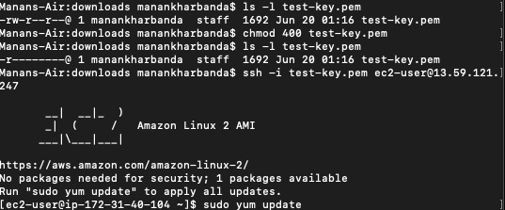

Installing Git

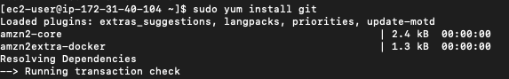

Basic Linux commands

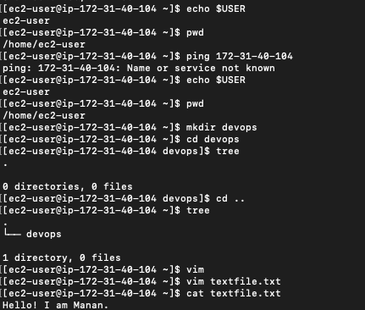

Using move, grep and find commands on a text file

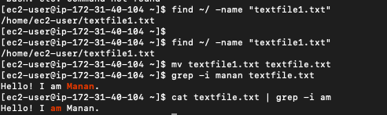

Creating .sh script with user input

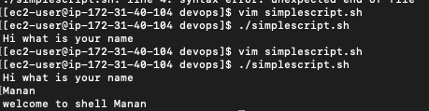

**Git Practice**

Git add, branch, status

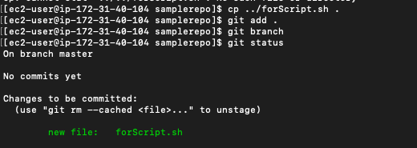

Git commit

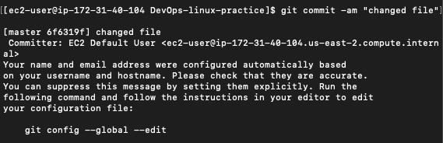

Git push

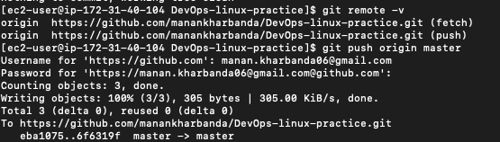

Git checkout and creating new branch

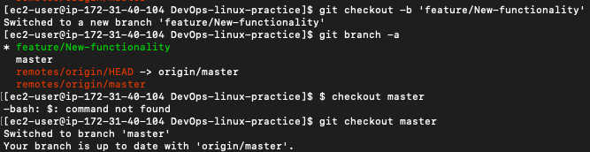



Adding JAVA_HOME variable

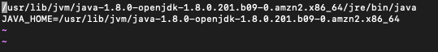



**Jenkins**



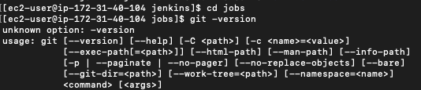

**Maven**



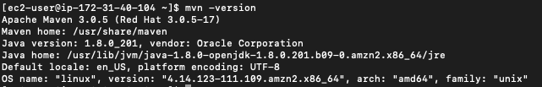

**Accessing Game-of life project**

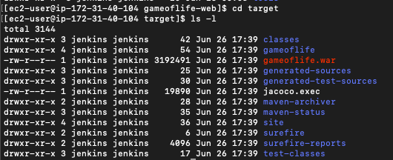

**Installing Urban Code deploy**





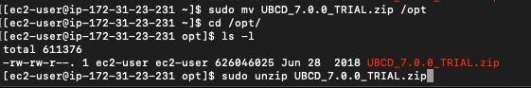

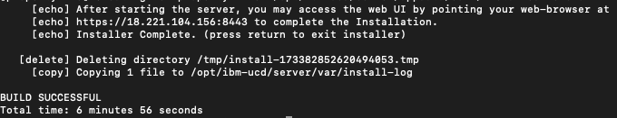

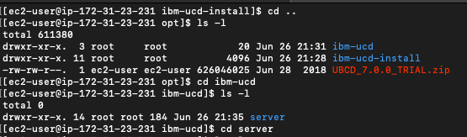



**Installing Agent**

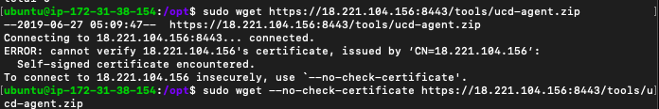

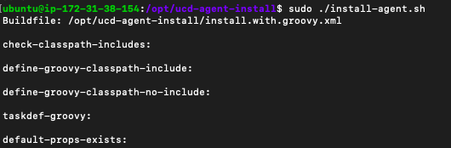

**Starting the Agent**

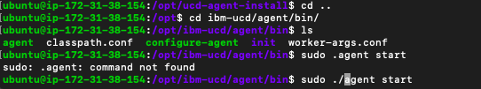

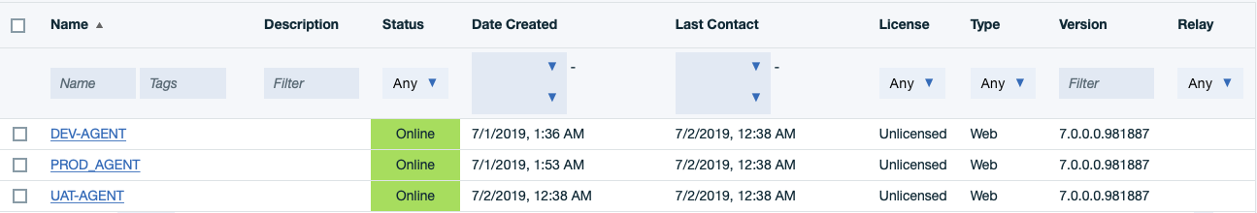

**Creating the process in UCD**

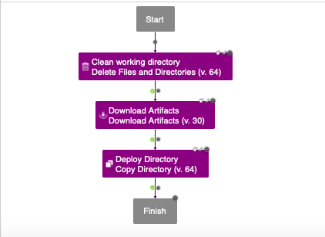

**Deployment in Dev Environment**

